Name: Marlou D. Dioneda Date: 11/06/24

Program/Course: BT- MECH Yr&Sec: 2D

TEST l. In any order, write down the parts of a micrometer.

1. Anvil
2. Spindle
3. Frame
4. Sleeve
5. Thimble
6. Clamp
7. Ratchet Stop

TEST ll. Reading the measurement of a micrometer.

1. **1.90 mm**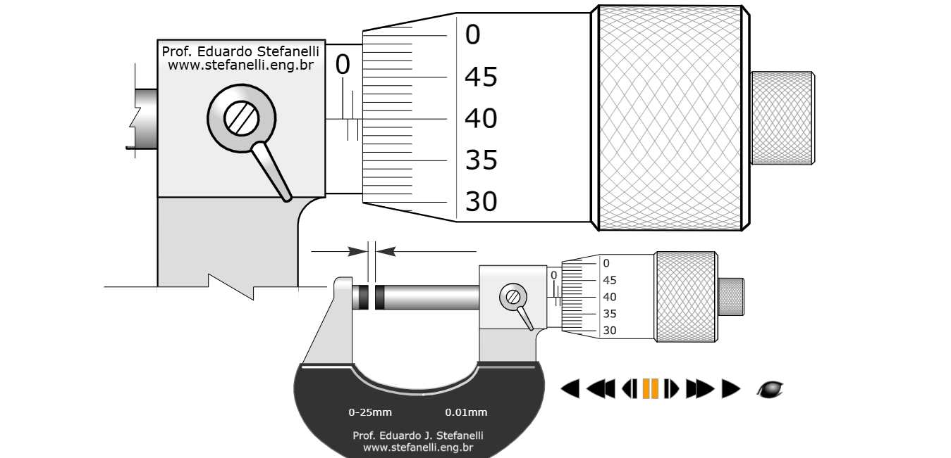

2. **12.9 mm**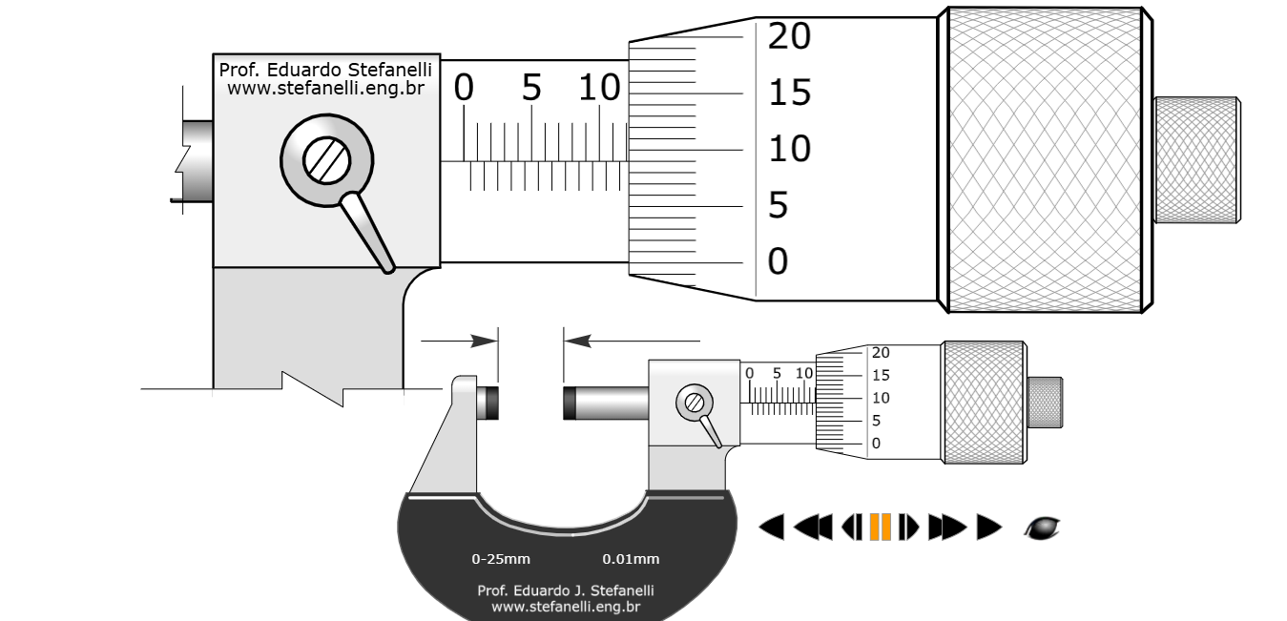

3. **5.95 mm**

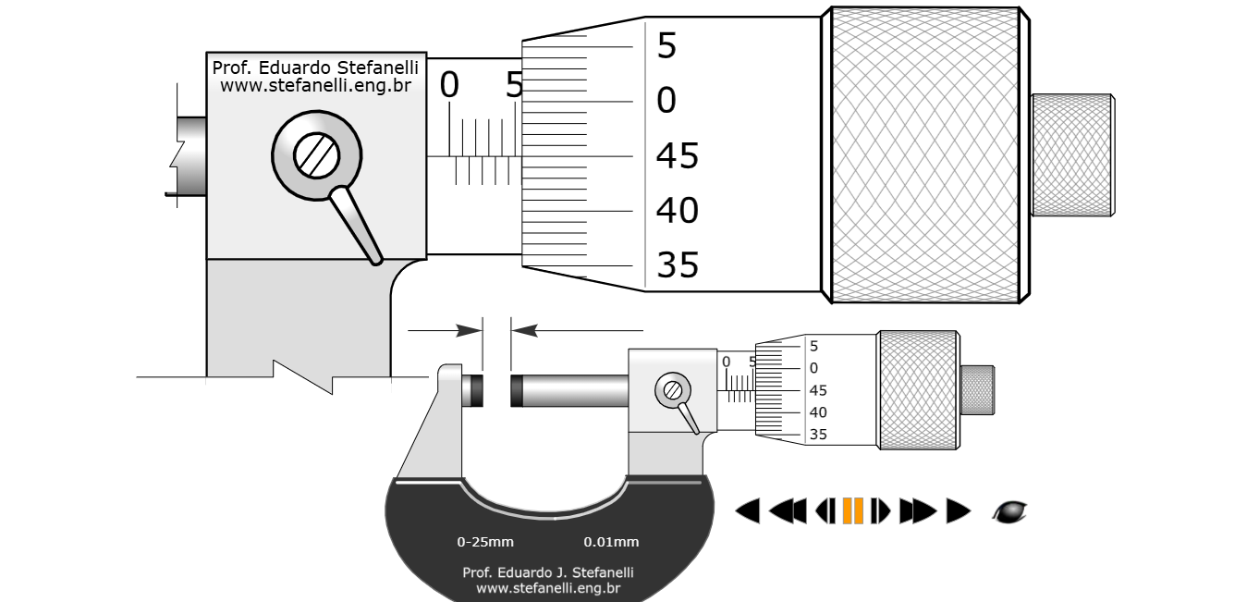

4. **13.60mm**

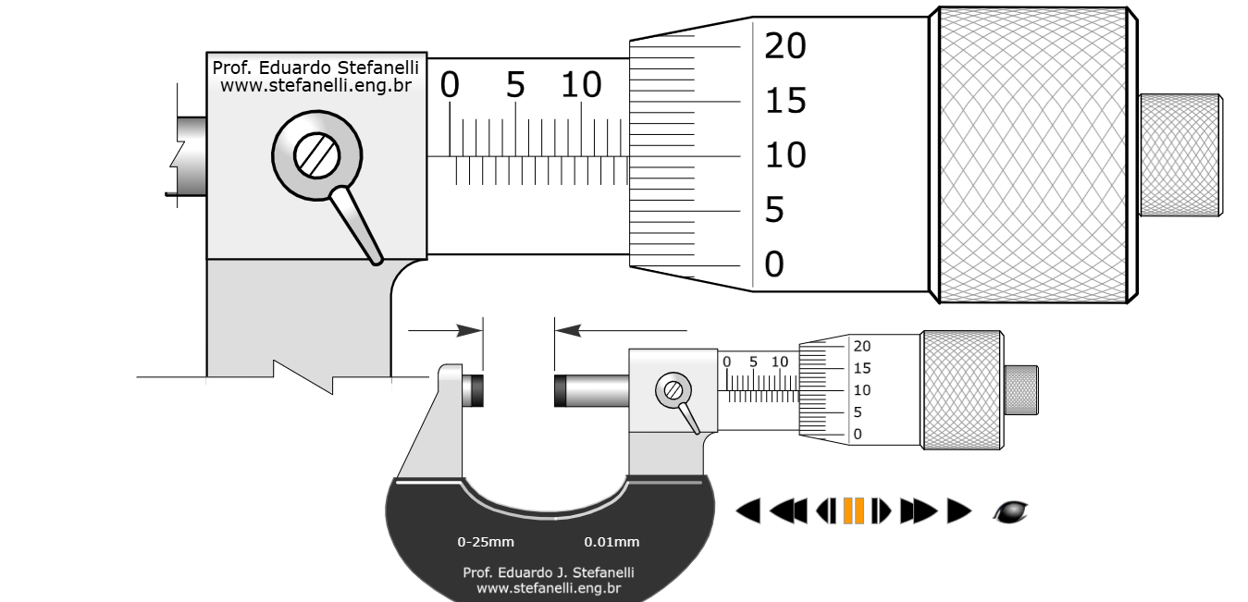5. **14.93 mm**

